**EXPERIMENT 12**

**AIM: Write a program which demonstrates Session handling in Express JS.**

**CODE:**

***npm install express express-session*:** Install Express and express-session middleware for session handling.

***npm init -y*:** Initialize a new Node.js project using npm init.

**index.js:**

const express = require('express');

const session = require('express-session');

const app = express();

const PORT = 3000;

// Parse incoming JSON and URL-encoded requests

app.use(express.json());

app.use(express.urlencoded({ extended: true }));

// Configure session middleware

app.use(session({

  secret: 'secret-key',  // Replace with a strong secret in production

  resave: false,

  saveUninitialized: true,

  cookie: { secure: false }  // Use 'true' only in HTTPS environment

}));

// Root route (This resolves "Cannot GET /" error)

app.get('/', (req, res) => {

  res.send('Welcome to the Session Handling Demo');

});

// Route to set session value

app.get('/set-session', (req, res) => {

  req.session.username = 'Vasantdada Patil College Of Engineering';

  res.send('Session value for username set!');

});

// Route to get session value

app.get('/get-session', (req, res) => {

  if (req.session.username) {

    res.send(`Session username: ${req.session.username}`);

  } else {

    res.send('No session username set.');

  }

});

// Route to destroy session

app.get('/destroy-session', (req, res) => {

  req.session.destroy(err => {

    if (err) {

      return res.send('Error destroying session');

    }

    res.send('Session destroyed!');

  });

});

// Start the server

app.listen(PORT, () => {

  console.log(`Server running on http://localhost:${PORT}`);

});

**OUTPUT:**

[**http://localhost:3000/**](http://localhost:3000/)**:** This will show “Welcome to the Session Handling”

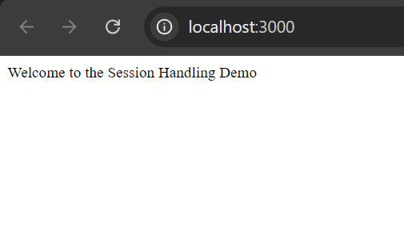

**http://localhost:3000/set-session:** This will set the session value username.

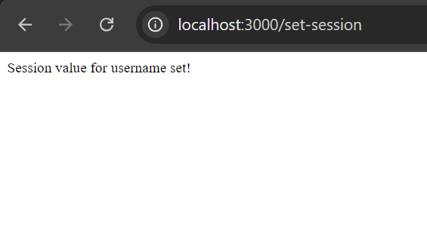

**http://localhost:3000/get-session**: This will retrieve and display the session username.

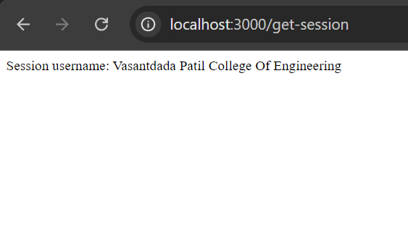

**http://localhost:3000/destroy-session**: This will destroy the session and confirm it with a message.

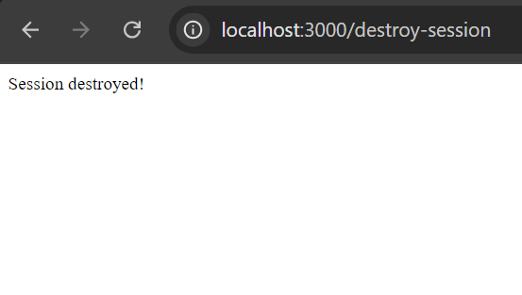

**CONCLUSION: Hence, we have successfully implemented a a program which demonstrates Session handling in Express JS.**